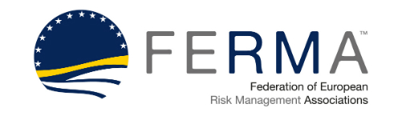 | 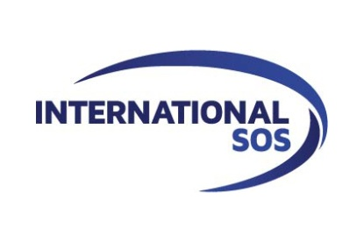

New Report on European Trends in Travel Risk Management

FERMA and International SOS outline risk and insurance managers’ responsibilities to travelling employees and expats

6 October 2015 – Venice.

Managing health, safety and security risks to workers on international travel and assignment is the subject of a new paper from the Federation of European Risk Management Associations (FERMA) and International SOS, the world’s leading medical and travel security risk services company.

A survey earlier this year* led by FERMA and International SOS, confirms that Travel Risk Management is on the agenda for 79% of the risk and insurance managers polled. FERMA and International SOS have, therefore, developed this paper to help risk and insurance managers better understand their responsibilities regarding work-related international travel and assignments.

The document identifies the Risk Manager as a pivotal influencer in evaluating effective Travel Risk Management solutions. As noted in the paper: “The risk manager’s holistic perception of the medical, security and insurance aspects is critical to considering efficient solutions and practical responses to any situation an organisation might face when sending workers abroad.”

The paper includes:

- A legal review of Duty of Care for organisations in Europe;

- Best practice and practical experiences from leading risk practitioners, representing Atlas Copco, CMI Groupe, DLA Piper, Drägerwerk, Kering, and Wolters Kluwer;

- A Travel Risk Management Toolbox that outlines health and travel security measures that organisations can implement to help reduce risks for their travellers and international assignees;

- A review of the transposition of the EU legislation in 15 Member States which shows that national laws vary always toward greater health, safety and security responsibilities for organisations concerning their workers.

Jorge Luzzi, FERMA board member with responsibility for the project:
“People are travelling on business more and further than ever before. This report will support organisations in fulfilling their duty of care to these travellers who are likely to be exposed to unfamiliar situations and increased risks compared to their home countries. FERMA recommends it to its members and all others involved in managing international travel for their organisations for both its practical and legal advice.”

Laurent Taymans, Regional Medical Director, International SOS, explains:
“In this rapidly changing economic environment, companies need to be able to implement robust and scalable solutions to protect their travellers and expats. There is a measureable benefit for understanding and mitigating health, safety and security risks. These are an increasingly vital component of the international business development strategy. There is much more to the eye in regards to prevention than just direct financial considerations. Risk and insurance managers now have a unique opportunity to reinvent their role and leverage support.”

Download a complimentary copy of the paper here:

* FERMA and International SOS conducted a 1-minute online survey from April to July 2015 to gather organisations’ practices and views of Travel Risk Management. Of the 191 respondents, Risk Managers were in majority (60%), Insurance Managers accounted for 20% and 20% were Risk and Insurance Managers.

About FERMA
The Federation of European Risk Management Associations (FERMA) brings together 22 national risk management associations in 20 European countries. FERMA has 4 500 individual members representing a wide range of business sectors from major industrial and commercial companies to financial institutions and local government bodies. These members play a crucial role for their organisations with respect to the management and treatment of complex risks and insurance issues.
ferma.eu

About International SOS
International SOS is the world’s leading medical and travel security risk services company. We care for clients across the globe, from more than 850 locations in 92 countries.
International SOS’ expertise is unique: More than 11,000 employees are led by 1,400 doctors and 200 security specialists. Teams work night and day to protect our members.
International SOS pioneers a range of preventive programmes strengthened by our in-country expertise. We deliver unrivalled emergency assistance during critical illness, accident or civil unrest.
International SOS is passionate about helping clients put Duty of Care into practice. With us, multinational corporate clients, governments and NGOs can mitigate risks for their employees working remotely or overseas.
internationalsos.com

Contact
Barbèl Gerlagh
Marketing Manager Benelux & Nordics, International SOS
T+31 (6) 3405 3861
barbel.gerlagh@internationalsos.com

Lee Coppack
Media coordinator, FERMA
T: +44 (0) 208 318 0330
lee@coppack.co.uk

